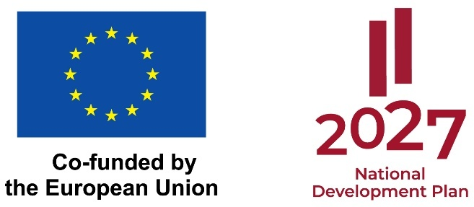

Progress Report on the implementation of the project for the mid-term evaluation of scientific quality

Project title:
Agreement No.:
Specific support objective/ activity number and title: | Activity 6.1.1.2 "Development of research for the sustainable use of natural resources in the context of environmental and climate objectives" of Specific Support Objective 6.1.1 "Mitigating the economic, social and environmental impacts of the transition to climate neutrality in the most affected regions"
Project applicant:
Start and end date of project implementation
Mid-term date
Submission date of the Report:

PROJECT PROGRESS SUMMARY

Progress in achieving the project objective and the implementation of the key activities, and project results achieved

PROJECT ACTIVITIES AND THEIR PLANNED AND ACHIEVED DELIVERABLES* AND MILESTONES**

No. | Name of project activity | Measures taken in the implementation of the project up to the mid-term stage | Planned deliverable and/or milestone | The deliverable and/or milestone achieved at the mid-term stage of the scientific quality evaluation, expressed in numerical terms
1.
1.1.
1.2.
…

*Results achieved through the activities.
**Milestones achieved within the framework of the project. Outcome and result indicators specified in the national regulatory framework of Activity No. 6.1.1.2 "Development of research for the sustainable use of natural resources in the context of environmental and climate objectives":
- The number of scientific articles for which support has been provided for their preparation and publication;
- Preparation and submission of research proposals for research grants;
- Companies that collaborate with research organizations.

- SCIENTIFIC EXCELLENCE

  - Course of the project implementation, achievement of objectives and results
  - The suitability of the chosen research methodology for the project’s objectives and its impact on the scientific quality of the results achieved

- IMPACT

  - Industry development and sustainability
  - Dissemination of results and measures for the transfer of knowledge or technology

- QUALITY AND EFFICIENCY OF PROJECT IMPLEMENTATION

  - Efficiency of resource use and project management
  - Quality of collaboration and partners’ contributions

- SUMMARY OF THE PROJECT BUDGET
Budget item | Budget expenditures for the implementation of activities | Costs
Budget item | Budget expenditures for the implementation of activities | Planned costs (total project costs), EUR | Costs spent as of the mid-term stage, EUR
TOTAL:

Efficiency of the use of financial resources:

LIST OF SUBMITTED DOCUMENTS

