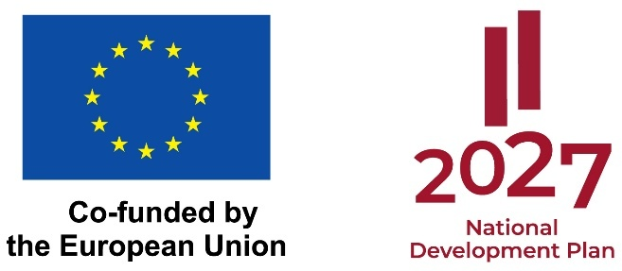

Progress Report on the implementation of the European Research Council Starting Grant project refinanced in the second round of Activity 1.1.1.5 for the mid-term evaluation of scientific quality
Methodology for completing the Mid-term Report

Project title: | Indicate the project title in accordance with the agreement/contract concluded for the implementation of the project
Specific support objective/ activity number and title: | Specific Support Objective 1.1.1 "Strengthening research and innovation capacity and implementation of advanced technologies in the overall R&D system".  Activity 1.1.1.5 "Latvia’s full participation in the Horizon Europe program, including ensuring a comprehensive range of support instruments and linking them to the development of RIS3 specialization areas"
Beneficiary of the funding: | Indicate the legal name of the project applicant without using abbreviations
Agreement No:
Start and end date of project implementation:
Submission date of the Report:
The Report shall include information on the progress of the project’s implementation, including the achievement of objectives and planned scientific results, as well as the progress of the project’s implementation for the purpose of evaluating the scientific quality of the results at the mid-term stage. When completing the sections of the Report, the mid-term evaluation criteria must be taken into account. Note: The project proposal submitted to Horizon Europe and its evaluation form (Evaluation Summary Report/Evaluation Report) will be made available to experts for the mid-term evaluation of scientific quality. The information included in the Report shall be based on the project proposal submitted to Horizon Europe and the planned progress and results achieved as described therein.
Where applicable, the Report shall provide an explanation of the results planned but not yet achieved as of the mid-term stage (e.g., delayed project activities) and propose a future work plan (including a timeline and available resources) to achieve the project’s objectives, scientific results, and outcomes by the end of the project implementation period.
Technical information: Files in PDF format can be attached to the Report. If additional documents are attached, the Report must include references to the attached appendices.
If a scientific article has been prepared and published as part of the project, its DOI must be included in the Report. If the scientific article is not available on the website for free public viewing, it should be attached to the Report as an appendix. It is recommended to include this as an appendix to the Report even in cases where the article has been submitted to a journal (or collection of articles) but has not yet been published at the mid-term stage, along with additional proof (e-mail, extract from the system) of the submission of the scientific article.

1.Project summary: Progress toward achieving the project objective, progress in implementing the key activities, and results achieved (no more than 2,000 characters, including spaces)
A brief and concise summary of the progress of the scientific work carried out under the project compared to what was originally planned in the project proposal, including information on progress toward achieving the project’s objectives and expected results. (Information must be provided for the period from the start of project implementation to the mid-term stage specified in the project proposal).
This section of the Report shall provide a brief summary of the information presented in the subsequent sections of the Report, without duplicating the information provided in those sections.

2. Progress of the scientific proposal’s expanded implementation, proving that the project still has ground-breaking nature and potential impact of the research project
The Report must provide detailed information on the progress of the project at the mid-term stage, describing how the work plan aligns with the project’s objectives and providing information on the progress made compared to the initial objectives and level of ambition. Provide information on any changes to the project implementation plan, if any. Describe how the expert recommendations indicated in the project proposal evaluation (Evaluation Summary Report/Evaluation Report) were taken into account (if applicable).

2.1. The project’s novelty and potential impact
Highlighting the project’s originality, level of ambition, and potential to make a significant impact (Ground-breaking nature and potential impact of the research project), describe:
- Mid-term progress, as evidenced by the results achieved, shows that the project remains “beyond the state of the art”;
- The balance of risks and benefits: whether the project retains its “high risk-high gain” nature, or has shifted toward safer, less ambitious goals;
- Impact potential: Do the results to date demonstrate the ability to address significant scientific challenges and maintain a high potential for impact? Justify this based on the results achieved.

2.2. Scientific approach and implementation
Describe the appropriateness and feasibility of the research methodology selected in the project proposal (as outlined in Part B1 of the “Research Proposal”). Describe how effective communication and task allocation are ensured within the team, briefly outlining the project implementation staff and the division of labor.

3. Contribution of the Principal Investigator (PI)
Provide a detailed description of the project’s implementation up to the mid-term stage, describing the PI’s ability to think creatively and independently when addressing research challenges:
1. What were the PI’s main responsibilities and tasks in implementing the project;
2. How the PI ensured the strategic direction of the project and addressed organizational or scientific challenges;
3. How the PI coordinated the team’s work and the use of resources to move toward achieving the project’s objective.

Provide examples of instances where the PI demonstrated an original approach to problem-solving that differed from traditional approaches and fostered innovation in the project.

4. Progress of implemented activities and achieved results
No. | Work packages (WP) according to original proposal | Description of the progress of the implementation of the activities  (Brief and concise information on the implementation of activities and achieved results) Information on what is still to be done in the implementation of the project within the specific activity | Planned results at the mid-term of the project | The result achieved at the mid-term of the project implementation in numerical terms
 |  |  |  | Number | Unit of measure
 | List all activities that have been initiated, in accordance with the Horizon Europe project proposal | A detailed description of the work completed under each activity, including the results achieved, in accordance with the original project proposal.  Describe the scientific value and level of novelty of the results achieved. A brief description of the quality of the project’s risk management.  In addition, briefly describe further work to be done within the scope of the activity until the end of the project. Specify the timeframe for implementing the activity (in months). | Indicate the planned results at the mid-term stage | Indicate the results achieved at the mid-term stage

5. SUMMARY OF THE PROJECT BUDGET
Detailed breakdown of the project budget
Cost item title | Work packages (WP) | Costs
Cost item title | Work packages (WP) | Planned costs (total project costs), EUR | Costs spent, EUR
For example, compensation, travel expenses… | List all work packages for which expenditures have been incurred in the relevant budget group.

Brief description of the resources used:
A brief and concise description (from the beneficiary’s perspective) of the effectiveness of the material and financial resources used. Describe the planned budget, how much has been spent so far, and provide a brief overview of where the project budget is planned to be spent.

