Instructions for Completing the Simplified FEC Model

1) Cover Sheet
Enter the name of the PPP project
Select the alternatives analysed for the implementation of the project
Indicate month and year of preparation of the FEC
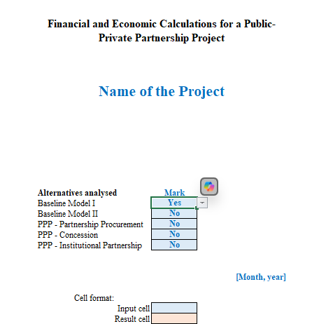

When completing the cover sheet, you must mark (Yes or No) all the alternatives. The model provides for two baseline alternatives, where the public partner can implement the project by itself, investing and bearing the other costs within the framework of its main activity, or by carrying out a public procurement in accordance with the contractual timeframes set by the applicable law. For the alternatives to be comparable, the timeframes in the alternatives must be the same. Depending on the scope of the project and the experience of the public partner, both baseline alternatives or only one can be filled in. The NPV worksheets will allow for the completion of the tables included, in accordance with the marks made on the cover sheet for the selected alternatives. If no alternative is selected, the corresponding NPV worksheet will display the message DO NOT COMPLETE and the tables will be inactive.
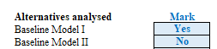

2) Assumptions
The Assumptions worksheet must show all assumptions, input data and sources used in the project calculations, so that all costs and revenues can be tracked in the cash flow statements:
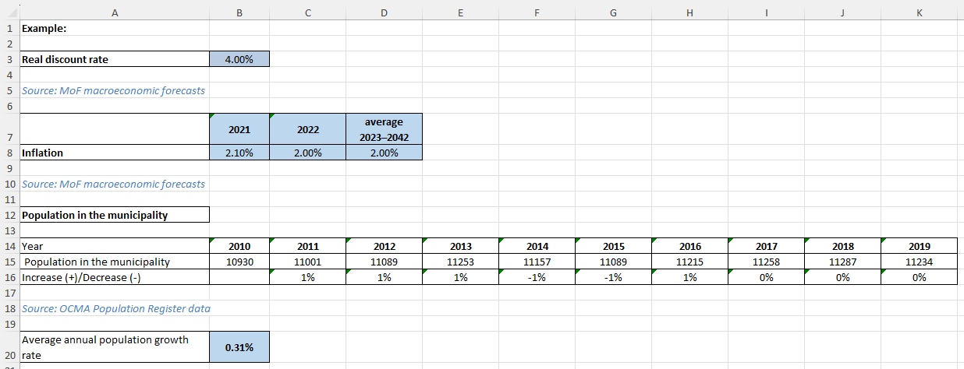
The Assumptions worksheet is essential to avoid manually inserting data separately into each worksheet, as the input data is entered only once and used accordingly in both the Project and NPV worksheets. To update an item, the change must be made in the Assumptions worksheet, not on each NPV worksheet. For example, the real discount rate (with a link to that specific cell) will be entered in all relevant cells of the NPV worksheets and further used to discount the cash flows.
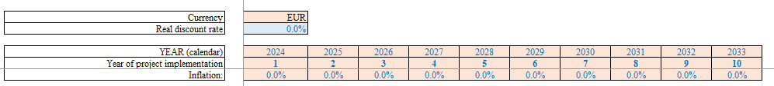
Separate assumptions can be entered in the Assumptions worksheet and completed in the Project worksheet according to the expected project implementation period. In the MoF's macroeconomic projections (available at https://www.fm.gov.lv/lv/makroekonomiskie-pienemumi-un-prognozes), the projected inflation rate is given for the next few years and for multi-year periods. Therefore, the inflation rates for each year can be entered in the corresponding row of the Project worksheet and the NPV worksheets can be linked to the corresponding cells of the Project worksheet. If inflation rates need to be adjusted, this must be done in the Project worksheet, but changes will be made automatically in the NPV worksheets. The calculated average population growth rate can then be used in the Projectworksheet to project population growth for further data. If these data change, they must only be updated in the Assumptions worksheet, while other worksheets that link to these source cells will be automatically updated.
Each project will have different assumptions and input data depending on its sector of implementation and the PPP model, so this section must be completed individually for each project.

3) Project
The overall cash flow statement for the project, including quantitative assumptions and financial estimates, is prepared in this worksheet. As the cost items vary from project to project, this form includes only the main items, which can be added or deleted. The purpose of this worksheet is to list and perform in one place all the quantitative and monetary parameters related to the implementation of the project, which are further used to complete the NPV worksheets of the alternatives under analysis, where only the financial information on the project appears. However, in order to arrive at the financial calculations, a number of quantitative assumptions are used, such as population projections, demand for a given service, solvency ratios, construction volumes, etc., which shape both the potential demand volume and projected revenues, and the cost components and their distribution across the different alternatives. A single accounting of project input data and estimates in the project cash flow statement avoids multiple entries in the NPV worksheets and the resulting errors.
When entering input data, it is mandatory to specify the quantitative and financial units of measurement in order to verify the completeness and correctness of the calculations made. It is also recommended that a detailed calculation of the cost and revenue projections to be filled in the NPV worksheets is carried out so that only the monetary totals under the relevant items are reflected in the NPV worksheets by linking to the relevant total items in the Project worksheet. For example, capital investments can be broken down in the NPV worksheets into construction-related items, indicating construction quantities, pricing and costing, and fixed assets, listing equipment to be purchased and other long-term assets. When performing calculations for the different project implementation alternatives in the Project worksheet, it is recommended to use the input data/assumptions that have already been entered, rather than re-entering them for each calculation block, e.g. population does not need to be re-entered for each alternative revenue projection, but the input data originally entered in the macroeconomic assumptions section must be used for the calculations.
The figure below shows an example of how to fill in one of the capital investment cost items - Construction costs. This total cost is made up of several components.
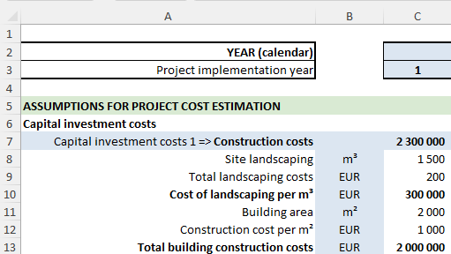
The Project worksheet also has rows for calculating project revenue, but note that not all projects generate revenue. If the project foresees the creation and maintenance of an asset without the provision of paid services, no revenue will be generated by the project and this section does not need to be completed in the Project and NPV worksheets. On the other hand, if the project foresees the creation of an asset and the provision of services on a user-fee basis (or with partial co-payment by the public partner), the calculation of the projected revenues must be reflected in the revenue section and the values must be indicated in the NPV worksheets of the respective alternatives.
In order to keep the NPV worksheets compact and clear, and to reduce multiple data entry and calculation errors, the relevant capital investment cost totals in the NPV worksheets must be linked to the relevant item(s) in the Project worksheet.

4) NPV worksheets
In order to enable the calculations and comparison of project implementation alternatives, five basic worksheets have been prepared in the FEC form according to the alternatives defined in the PPP Law and the guidance material (Baseline Model I and II, Partnership Procurement Model, Concession Model and Institutional Partnership Model). The main difference between these worksheets is the possible allocation of costs between the partners, as well as the inclusion of typical costs for certain models in the cash flow statement. Although each model's cash flow statement is tailored to its typical costs and the allocation between the public and private partner, it should be borne in mind when preparing the calculations that changes may need to be made, both additions and deletions of unnecessary rows.
When completing the NPV worksheets, please note the following:
- According to the instructions on the cover sheet, data entry must be done in the blue cells, while the red cells already contain the calculation formulas and therefore do not require any action;
- Depending on the table of analysed alternatives completed in the cover sheet, a mark will appear in the title section of the NPV worksheets to indicate whether it needs to be completed. For alternatives that are not analysed in the FEC, the cash flow statement tables will not be active. To display them, mark the relevant alternative in the Cover Sheet and the tables will be activated.
- In the tables, it is possible to add additional columns for the project implementation period (years) and for the cost rows (items). In order for the formulas included in the form to perform correct calculations, the column/row containing "..." must be selected and it must be ensured that the additional column is inserted before the "..." and the row above the "..." column/row.
Excess columns/rows can be hidden.
- When completing the cash flow cost/revenue items, the corresponding item names as used in the Project worksheet must be indicated, e.g. "Capital investment costs 1" must be corrected to "Construction costs" and "Capital investment costs 2" must be corrected to "Investments in fixed assets".
- Cost items in the NPV worksheet items must be inserted with a link to the relevant item totals cell/row in the Project worksheet. When entering data into the NPV worksheets, attention must be paid to the symbols of the input cell. Costs should be indicated with "-", while the revenue symbol does not need to be changed when linking data to the Project worksheet.
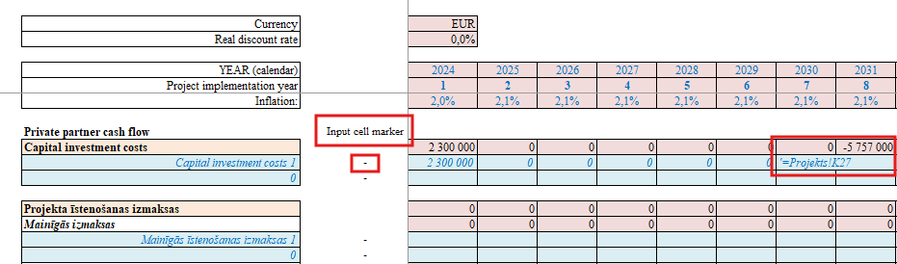
- To perform the IRR calculation, the Excel IRR function must be used in the relevant cells in each alternative - although the values domain will be the total cash flow of the calculation, the assumption (Guess) used to obtain the discount rate at which the revenue flow equals the cost will be different in each alternative.
- The completion of the public partner and private partner risk cost allocation section of the NPV worksheets is described in section 5) Risks.
- Depending on the specifics of the project, the estimated contract price row must also be completed, as it may be derived from different factors for each project, e.g. as a total cost, a total revenue or as a combination of availability payment and revenue.
- It must be ensured that the overall cash flow of the private partner is not only positive, but also in line with a certain level of profitability in the sector, in order for economic operators to be interested in participating in the private partner selection procedure. If the private partner's projected cash flow is not in line with industry averages, it is possible to include the private partner's mark-up in the cash flow.
5) Risk Analysis
The identification of risks and the quantification of the costs of preventing the risks of the PPP model must be carried out in the Risk Tool, and the information obtained in the Risk Tool must be reflected in the Risks worksheet.
Only risks for which a cost of risk has been identified must be listed in the Risks worksheet of the financial model. The allocation of risks must be carried out in such a way that the respective risk is borne by the counterparty that is better able to influence or manage the probability of the occurrence of the risk, or to control or absorb its impact. When using the Risk Tool, it must be noted that the risk can be transferred to the public partner, the private partner or jointly to both partners (three options) in the partnership contract. Two or all three options are not possible at the same time. The risk must be transferred either to the private partner or to the public partner, or it must be indicated that the risk is shared between the private and public partner. The respective mitigation costs of each party must be provided where mitigation measures are possible for the risk concerned.
Risk analysis must determine the probability, impact and value of a given risk, identify mitigating actions and monetise them.
Probability of risks. Reflects the probability with which the risk is assessed to occur (on a scale of one (1) to three (3)). If the probability of a risk is assessed as high (three (3)), it may jeopardise the implementation of the project. When assessing the risks affecting the project, each risk is assigned a probability level (1, 2 or 3).
Impact of risks. To determine the impact of each risk, risks are analysed according to their degree of impact on the project. If the impact of the risk is one, its occurrence will not have a significant impact on the implementation of the project. If the impact of the risk is high (three (3)), its occurrence may jeopardise the implementation of the project. When assessing the risks affecting the project, each risk is assigned an impact level (1, 2 or 3).
The risk score is the result of multiplying the probability of the risk by the impact of the risk.
Risk allocation. The aim of risk allocation is to transfer the management of each risk to the partner best placed to manage it qualitatively and minimise the cost of its occurrence.
The costs of risk are calculated taking into account risk mitigation measures and are determined by the expert method. Examples of costs of risk mitigation measures:
- To mitigate construction quality risks, the services of a construction expert are needed. The relevant costs of the construction expert will be risk mitigation costs.
- The cost of obtaining construction insurance policies, performance bonds will be risk mitigation costs.
- The cost of bringing in specialists to carry out monitoring activities.
The risk score is the probability of the risk multiplied by the impact of the risk, which can be 1, 2 or 3, respectively the possible risk scores are 1, 2, 3, 4, 6, 9. Costs must be identified for risks with a risk score of nine (9) or six (6). The FEC descriptive document must also include the cost of the occurrence of the risk (potential loss).
If the risk score is four (4), the cost of preventing the risk can be optionally determined.
If the probability of the risk is high (3) and the impact of the risk is low (1), then the risk does not need to be quantified. If the probability of the risk is low (1) and the impact of the risk is high (3), then the cost of preventing the risk can be optionally determined. In this case, the FEC descriptive document must also indicate the cost of the occurrence of the risk (potential loss).
For risks with a risk score of two (2) or one (1), the cost of preventing the risk does not need to be determined.
In the Risk Tool, it is possible to have a risk score of zero (0), meaning that the risk does not exist.
Not all potential risks need to be quantified as not all of them have a material impact on the Financial Model (Excel). Construction, availability and demand risks, as well as those risks that are of major importance due to the nature of the PPP project, are mandatory to be quantified. In the case of a PPP project involving construction, the risks associated with construction that may affect the construction process must be quantified. On the other hand, if the PPP project involves the provision of a service, the focus is more on the risks of availability or, in the case of a Concession, on the risks of demand.
Note that the relevant risk present in the PPP Model may not be present in the Baseline Model. If the risk is present in both the PPP Model and the Baseline Model, the mitigating actions may differ.
The cost of the occurrence of risks is not included in the cash flow of the Financial Model (Excel) as it is the probable cost of the occurrence of the risk. If the cost of the occurrence of risks is high, resulting in a significant impact on the project, then mitigating actions can be foreseen for the risk and included in the (Excel) cash flow.
To quantify the risks for each of the project implementation alternatives, a separate table has been created in the Risks worksheet, which provides the basic data for determining the cost of the risk:
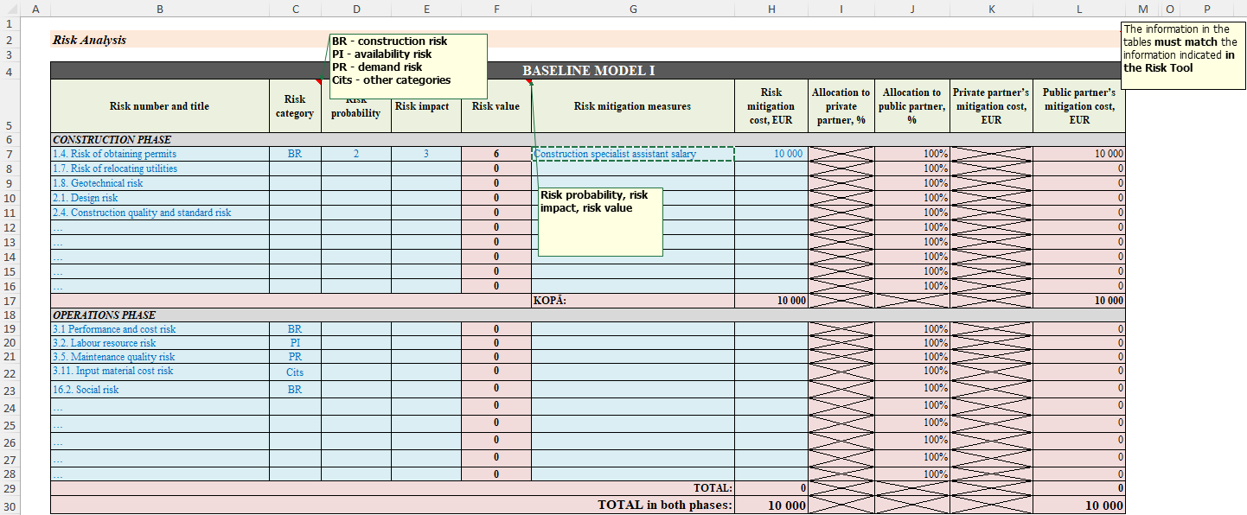
A risk analysis must be carried out for both the public partner and the private partner, as the risk analysis calculates the cost of risks that need to be included in the total cash flow of each partner in order to correctly determine the NPV of the cash flow and to ascertain whether there will be sufficient incentives for both partners to participate in the project.
The risk analysis must indicate:
- Risk factors, taking into account the specificities of the implementation of each alternative.
- Risk category according to the options indicated in the menu (CR - construction risk; AR - availability risk; DR - demand risk; Other - other risk category) assigned to each of the identified risks.

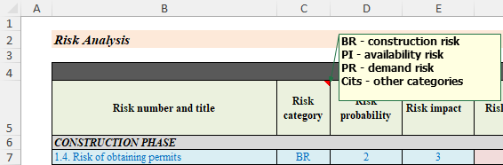

- Risk Probability, Risk Impact and Risk Score (calculated automatically) must be provided in accordance with the above risk score determination methodology.
- Indicating the share of the risk to be transferred to the private partner will result in a calculation of the % of the risk to be transferred to the public partner, as well as the cost of the risk in EUR for both partners. The costs of risk prevention are calculated taking into account the risk mitigation measures and are determined by the expert method. For example, to mitigate construction quality risks, the services of a construction expert are needed. The relevant costs of the construction expert will be the costs of risk prevention.
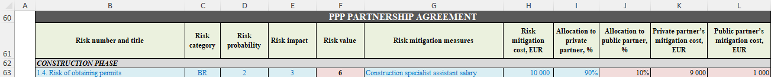
Risk quantification tables must be completed for each of the alternatives analysed, adjusting risk factors and quantifiers where necessary.
In addition, the Risk Analysis Summary will calculate the total cost of risk for each of the project implementation alternatives in four categories, as well as the % of risks to be transferred to the public partner.
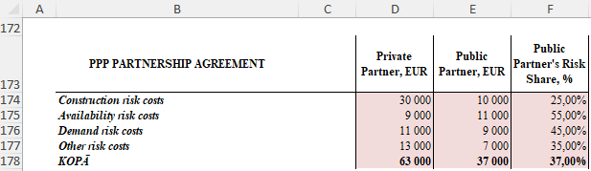
This analysis can be used to provide a detailed explanation in the descriptive part of the financial and economic calculations.
The next step is to complete the public partner and the private partner's risk costs in the NPV worksheets. As part of the risk analysis, the total costs of the risk items and the total costs for the three main risk groups are calculated for each alternative. These are the total costs during the entire project implementation period, but the NPV worksheets need to reflect the costs of risk in each year of the project and these costs also need to be discounted. To do this, it is necessary to understand the proportion of each project item that generates costs for each risk group.
If one of the alternatives is not analysed, the corresponding risk analysis and rate tables do not need to be completed. It can be closed using the grouping tool on the left side of the worksheet.

6) Sensitivity Analysis
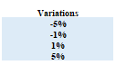
Sensitivity analysis must be carried out on the most significant assumptions affecting the financial models. These can be quantitative (e.g. population or consumer indicators influencing demand for the service) or qualitative (e.g. estimates of individual cost items). All four basic models are included in the form, but if any of them is not used in the calculations, that model can be closed or deleted and no calculations are required.
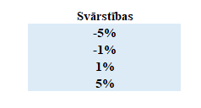
In the Sensitivity Analysis worksheet, the variation intervals to be used in the calculations must first be determined. Although the most commonly used +/- 1% and +/- 5% are defined in the form, they can be changed, for example, to +/- 5% and +/- 10%.
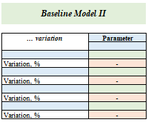
In the next step, the remaining data fields must be filled in sequentially:
- Indicate which parameter's "... variation" will be assessed, e.g. "Construction cost variation" or "Population variation".
- In the blue cells at the bottom, select the predefined variation intervals from the drop-down menu.
- In the Parameter cell, specify which of the calculation outputs (most commonly NPV, but can also be the total of the estimated contract price) the sensitivity analysis is performed against and enter the initial calculated value of that parameter. This value must be entered with a link to the cell of the specific NPV worksheet.
- To fill the green cells, i.e. to calculate the value of the parameter at the corresponding variation intervals, a correction of the parameter with the variation values has to be performed. As the NPV worksheets are completed using the links from the Project worksheet, the sensitivity analysis must be carried out by adjusting the parameter values by the selected intervals (-5% variation corresponds to a factor of 0.95; -1% to 0.99; 1% to 1.01; 5% to 1.05). This rate is applied to all cells of the corresponding item in the Project worksheet.
- As the data in the NPV worksheets are entered using links from the Projectworksheet, the calculations in the NPV worksheets, including the parameter values, will be updated automatically when an adjustment is made in the Project worksheet. To perform the sensitivity analysis, after applying each adjustment to the relevant variation, the value of the parameter must be entered from all NPV worksheets in the green cells of each model. These cells must not contain a link to the NPV worksheet cell, as the next adjustment will change its value and the analysis will not be correct.
- After all four scenarios have been analysed and the rates removed, the initial value of the parameter will be returned to its unadjusted value and the impact of the variations in percentage terms on the selected parameter will be calculated in the tables for the analysis of the assumptions of each model.
The example shows the original calculation from the Project worksheet. It generates project revenue by multiplying the consumer (80% of the total population) by the fee.
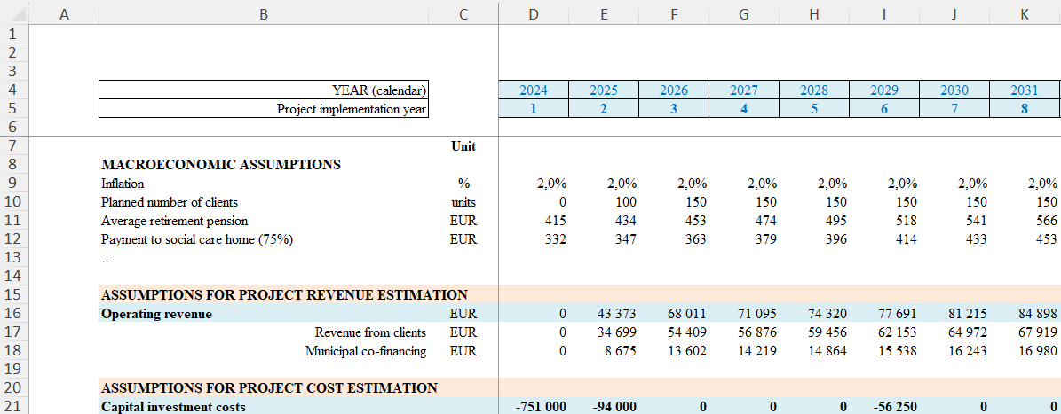
Population growth is calculated by multiplying the previous year's population by the average annual growth calculated in the Assumptions worksheet. To perform a sensitivity analysis on the number of consumers parameter, it is possible to apply a correction rate to both the number of consumers and the number of population in a row cell.

Once the calculations for all four adjustment scenarios have been made and the calculated NPV values entered, the NPV variations for each scenario are calculated in the sensitivity analysis table. They must be analysed in the context of the defined intervals.
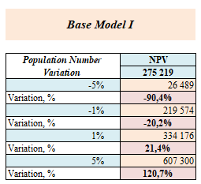
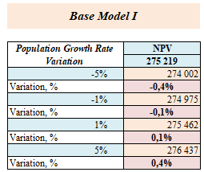
In this example (on the left in the figure) it can be seen that although the initial assumption - population - has been changed at relatively small intervals, the NPV has decreased/increased several fold. This means that this parameter is "sensitive", as changes in it lead to disproportionately large changes in the result of the calculations. In this example, however, it should be noted that the variation intervals are larger than the assumption used in the project that the population grows by an average of 0.31% per year. If only the average population cell in the Assumptions worksheet is adjusted instead of the population row in the Project worksheet (on the right in the figure), the results are reasonable. It is therefore important to consider which parameter and which worksheet(Assumptions or Projects) the variation adjustments are made to, so that the resulting sensitivity analysis calculations are meaningful and proportionate.
To carry out a sensitivity analysis for several assumptions, it is necessary to copy the calculation tables, specify the parameter and the assumption to be analysed and carry out the calculations. It is also possible to analyse the same assumption against a number of parameters, for example to assess how changes in an assumption affect the NPV and the expected value of the contract price.

7) VFM
The VFM worksheet calculates the value for investment compared to the baseline models, as well as the estimated contract price for all alternatives. There is no need to enter anything in the calculation table, as the relevant cells will be filled in once all the data has been entered in the NPV worksheets of the alternatives analysed. Graphs have also been produced to illustrate more clearly both the values for investment and the estimated contract price under the different alternatives.
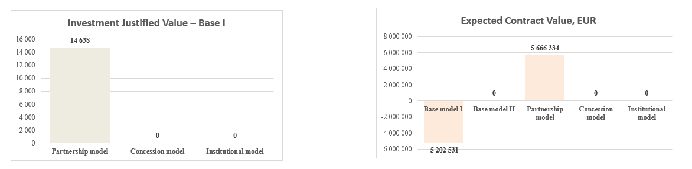

8) Statistical Treatment
To assess whether a project can be included on or off the balance sheet, the PPP risk allocation tool (please use your browser’s built-in page translation) available on the CFCA's website https://ppp.cfla.gov.lv/ must be used, creating a separate Excel file and attaching the calculations to the statistical treatment worksheet.

9) Development of the FEC Descriptive Document (Word)
The FEC must be prepared using the "Financial and Economic Calculations Form for Public-Private Partnerships" (word file), which is based on the "Guidelines for the Development of Financial and Economic Calculations for Public-Private Partnerships" developed by the CFCA. The financial and economic calculation form (word file) and the "Guidelines for the Development of Financial and Economic Calculations for Public-Private Partnerships" are available on the CFCA's website https://www.cfla.gov.lv/lv/finansu-un-ekonomiskie-aprekini (please use your browser’s built-in page translation).

According to Section 1 (32) of the Law on Public-Private Partnership - the total payment for the performance of a public-private partnership contract (not taking into consideration the value added tax). It also applies to the total amount of the financial resources (not taking into consideration the value added tax) the private partner would obtain by exercising the rights and obligations ensuing from a public-private partnership contract and that may also include payments of an end-user.
Available at https://ppp.cfla.gov.lv/ (registration required, please use your browser’s built-in page translation)
Recommendations for risk mitigation actions available at https://www.tandfonline.com/doi/full/10.1080/15309576.2020.1741406#abstract; https://www.foxmandal.in/anatomy-of-risks-in-ppp-projects-in-india-and-how-to-mitigate-them/; https://pure.spbu.ru/ws/files/19637708/Risk_management_in_public_private_partnership_projects_1939_6104_16_4_155.pdf (sources reviewed 25.09.2024.)
Potential risk scores (risk probability x risk impact): 1x1=1; 2x1=2; 3x1=3; 1x2=2; 2x2=4; 3x2=6; 1x3=3; 2x3=6; 3x3=9. Score 3 is formed from 1x3 or 3x1, meaning either high probability or high impact.

